# Department of Computer Science

**CS302: Database Systems**

**Class: BS/ADP (CS/CYS/SE/AI)**

# Lab 2: Database Application Using Microsoft Access

# Lab Instructor: Mr. Hamza Javed

**Introduction:**

Microsoft Access is a software application used for the purpose of creating and managing databases. A database is essentially a collection of useful records. The data stored in databases include several types of information, such as telephone directories, employment details, and academic records. Computerized database management systems (DBMS), like Microsoft Access, are specifically intended to efficiently handle large datasets, even if the effort of managing and organizing all this data may be time-consuming and challenging.

**Objectives:**

After performing this lab, the students should be

* + familiarized with Microsoft access
  + Create a database and tables
  + Explore structure of tables in a database
  + Create user form and explore structure of form
  + Create report form

**Tools/Software Requirement:**

Microsoft office 2016 or latest

**Description:**

**Starting Microsoft Access**

1. Click on **Start (windows 10)**
2. Search Microsoft access
3. Click on the application Microsoft Access **2016**

**Creating A New Database**

To create a new database, choose **Blank Database** and specify a new file name for the database, then press **Create**. The name of this database is **MYUstudent**.

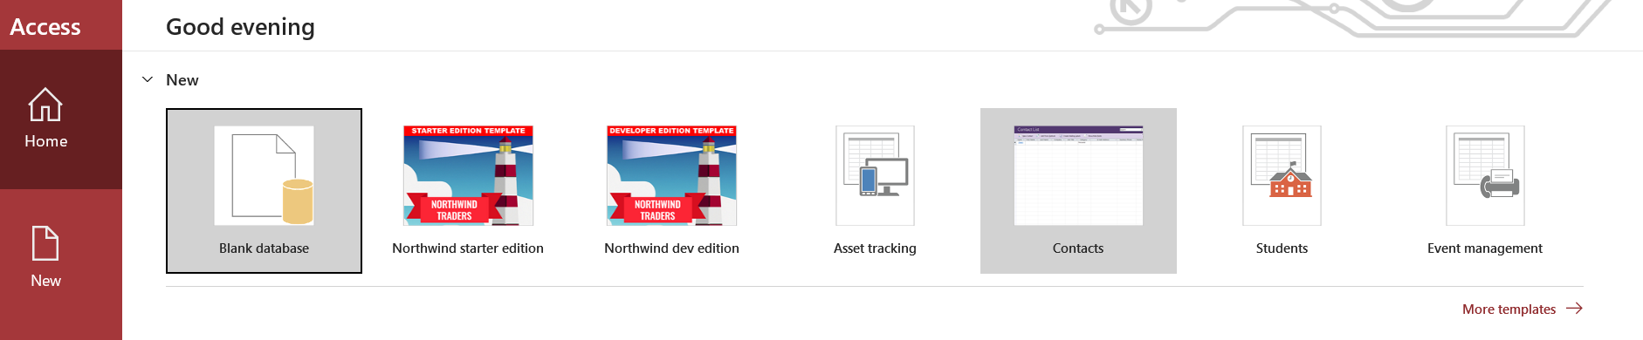

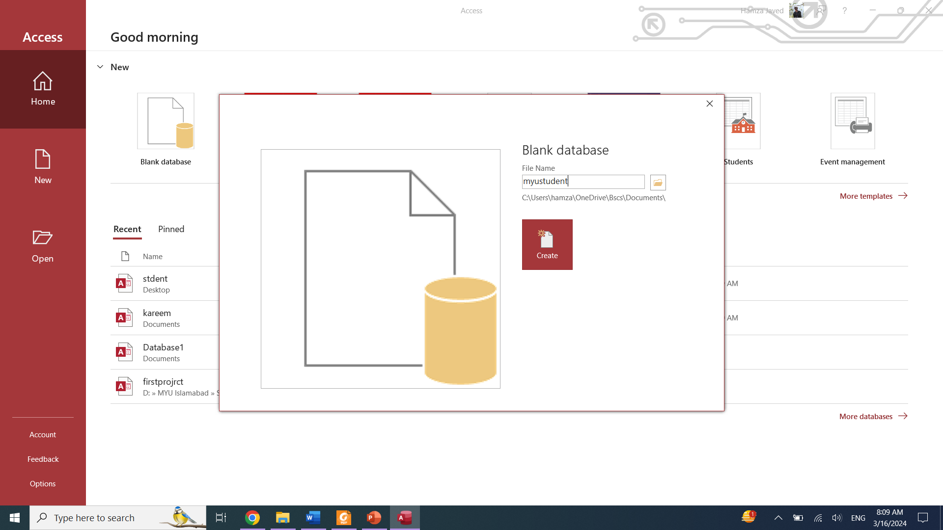

**Creating A Table:**

The database consists of a collection of tables. Once the database is created you need to create tables to work with that database. To create a table, you must describe the structure of the table to access by describing the fields within the table. For each field you must indicate the following:

1. FIELD NAME - each field in the table must have a unique name
2. DATA TYPE - indicates to Access the type of data the field will contain
3. DESCRIPTION - Allows you to enter a detailed description of the field.
4. FIELD SIZE
5. PRIMARY KEY



Click Create Button to create table

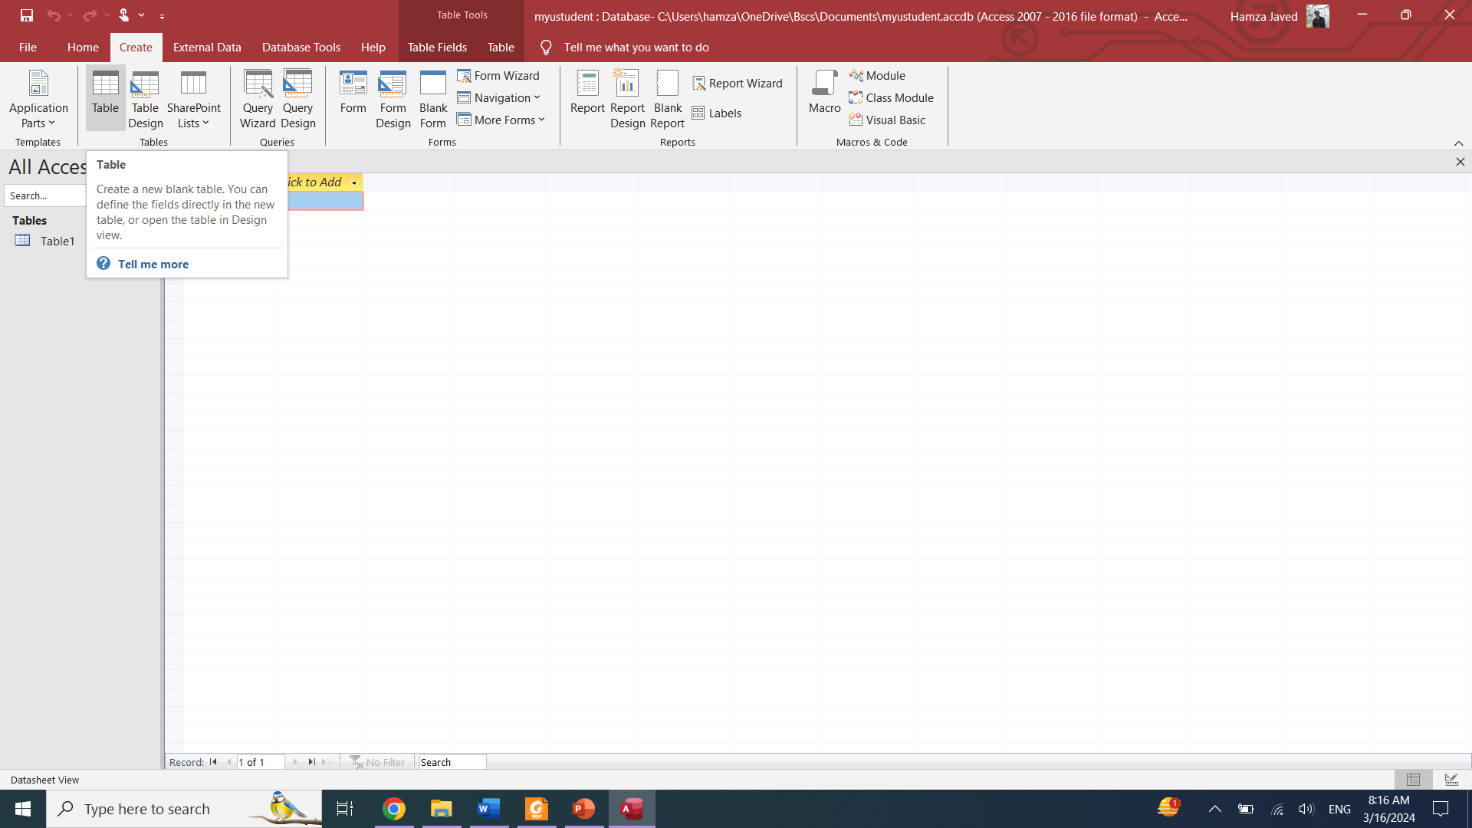

Right click on open table tab like: table1 and save the table with specific name

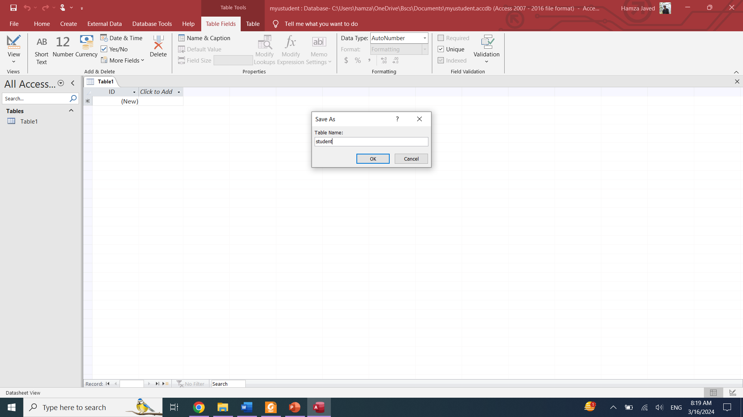

Right click on table: **student** table1 and select design view

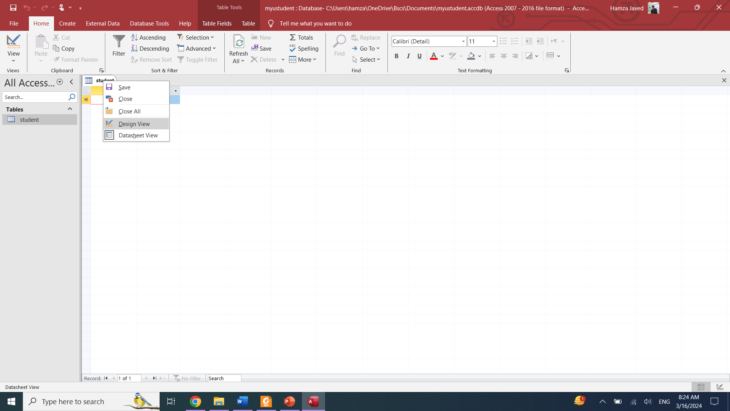

**Create Table field:**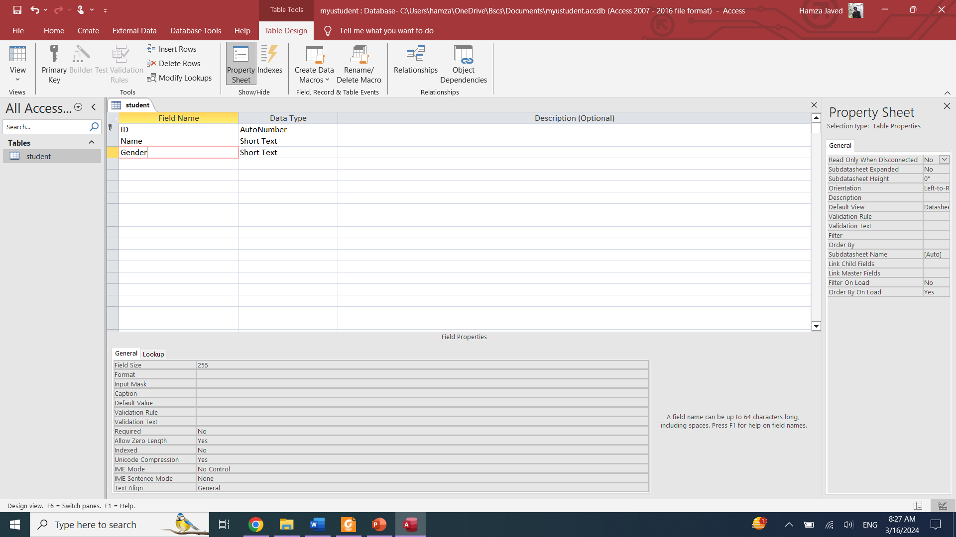

**Creating Gender Field:**

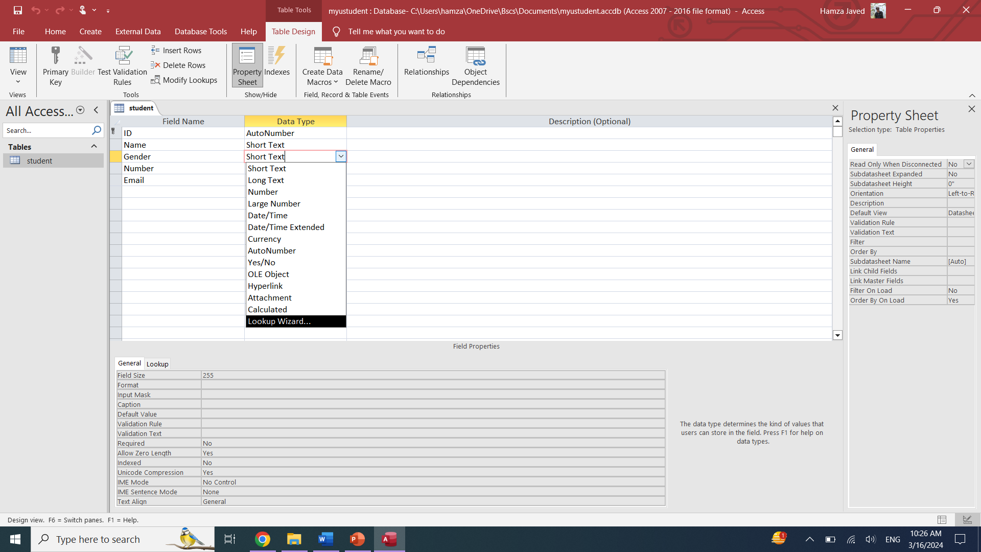

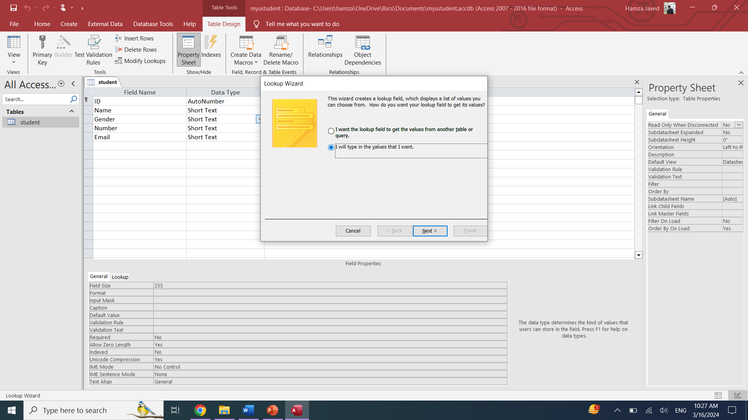

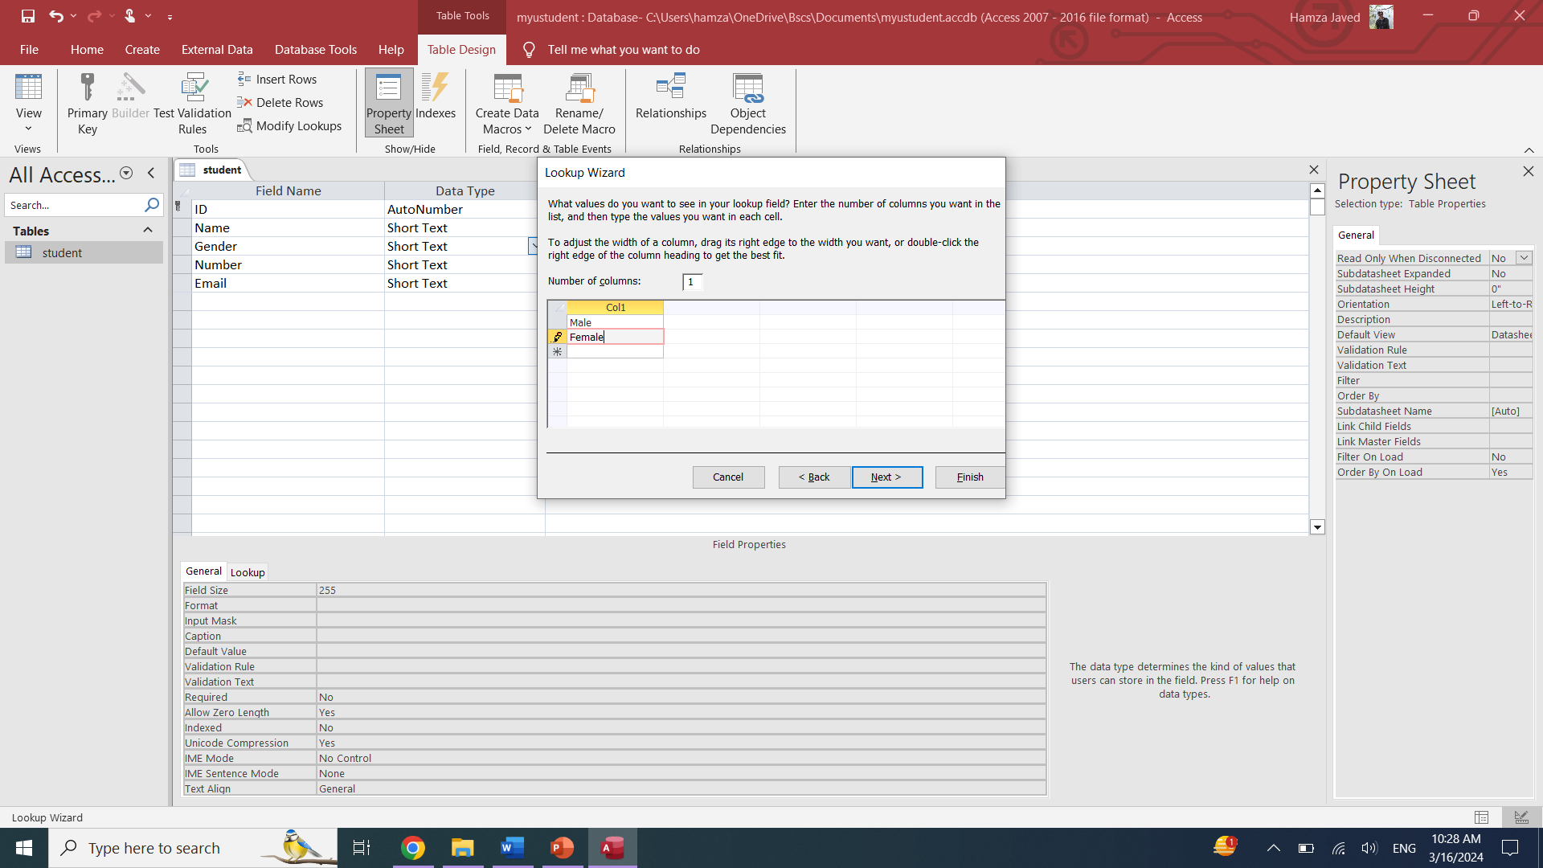

**Phone Validation:**

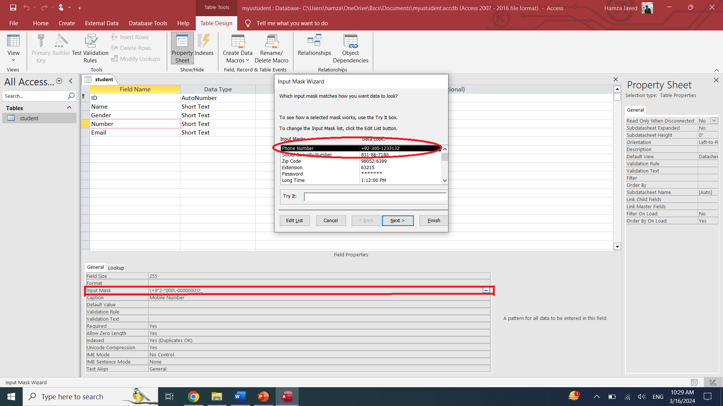

**Email Validation:**

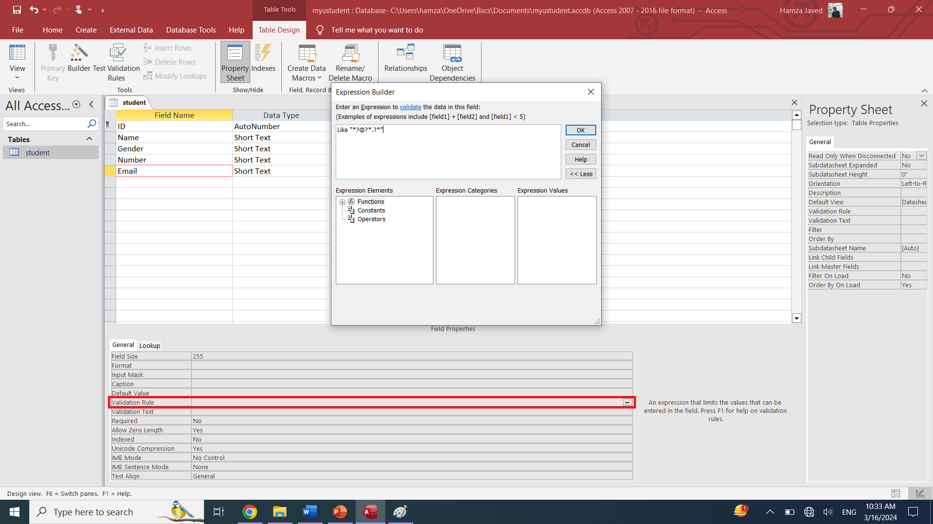  
Some more Field Properties are also shown, you may use it according to requirement

**Creating Form:**  
Click Create Button and click on form wizard

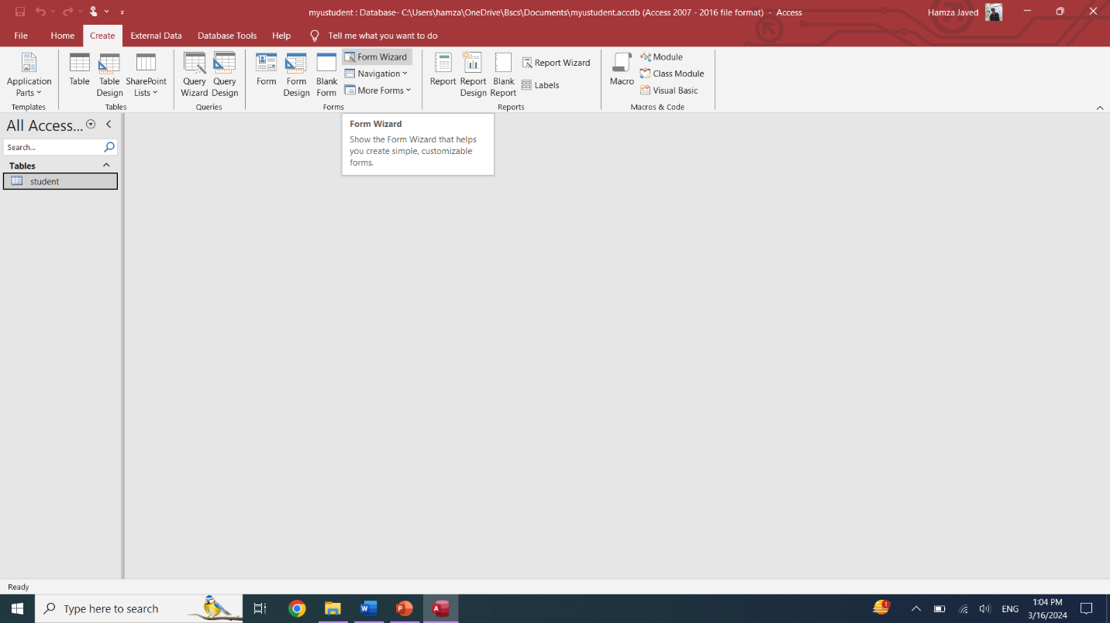

Select item you want to use in form

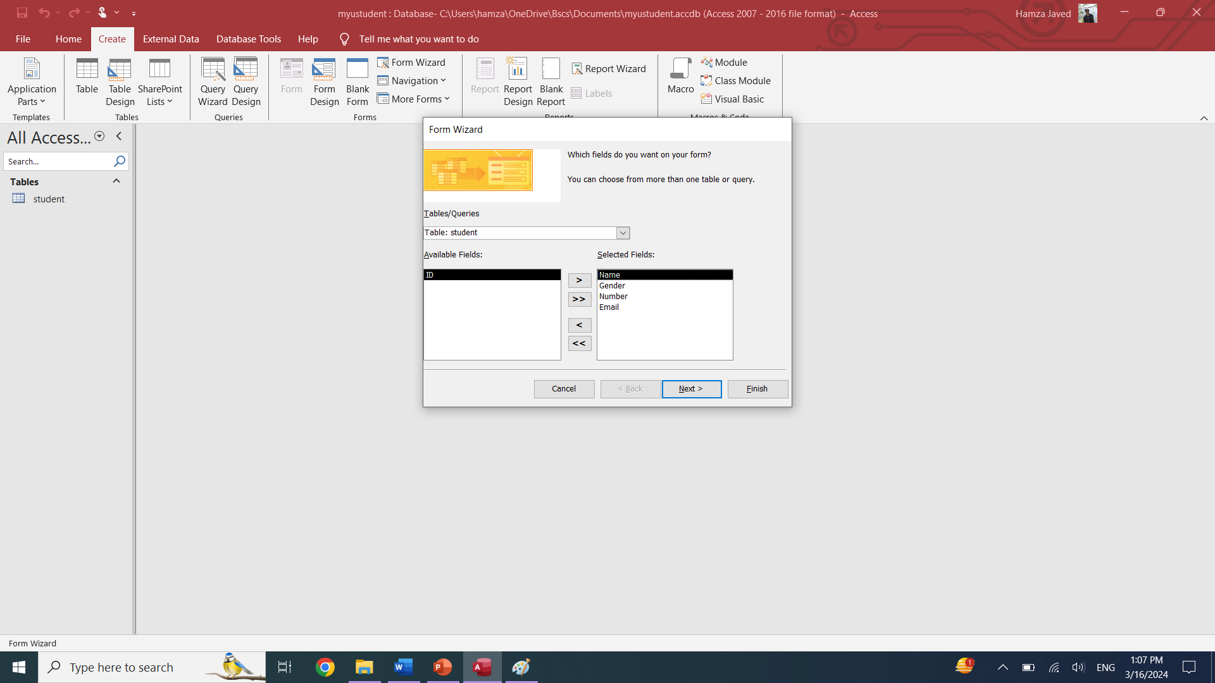

Select Form Layout

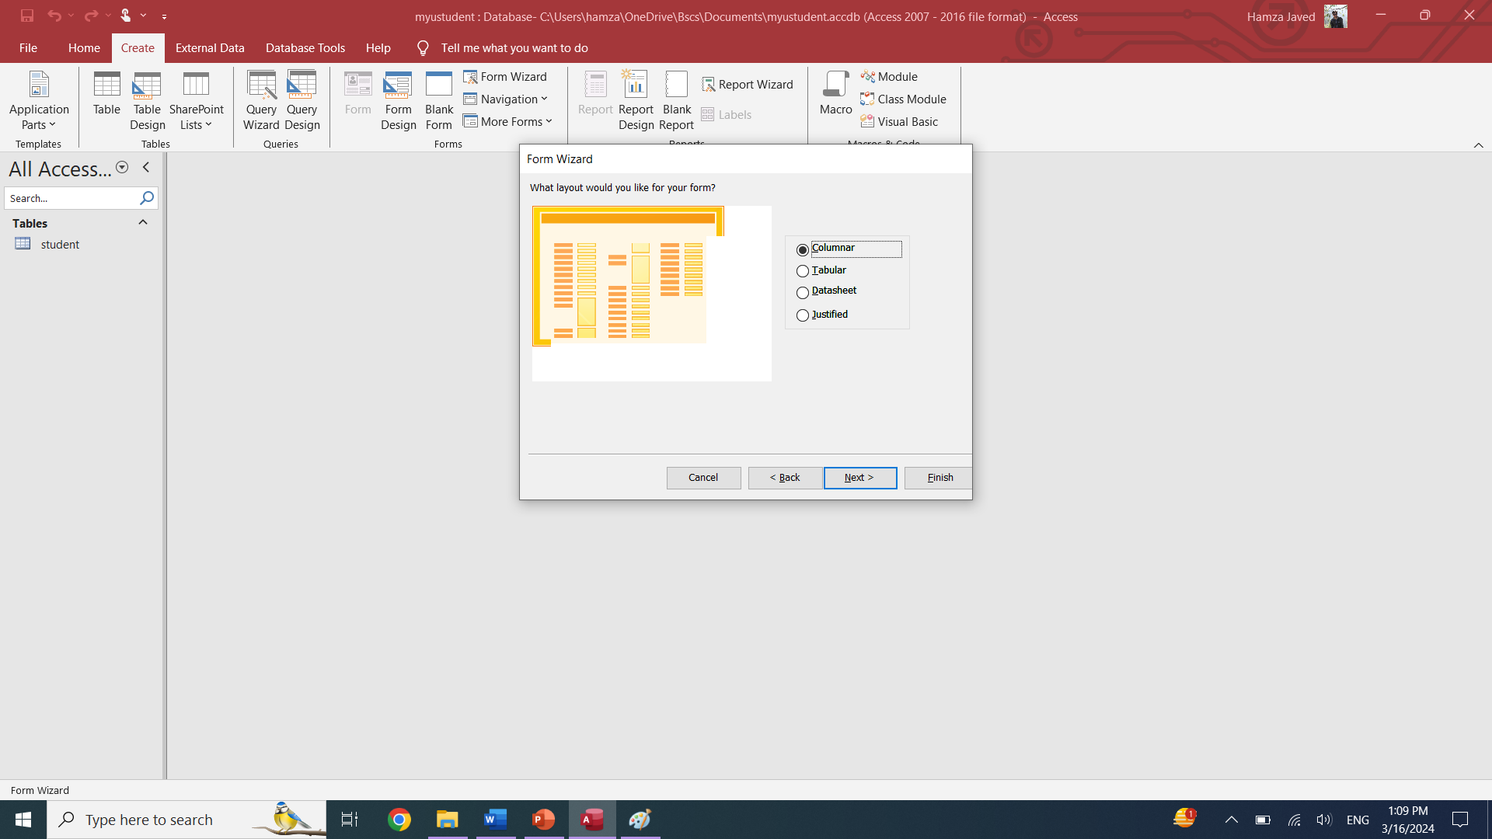

Click next and then finish

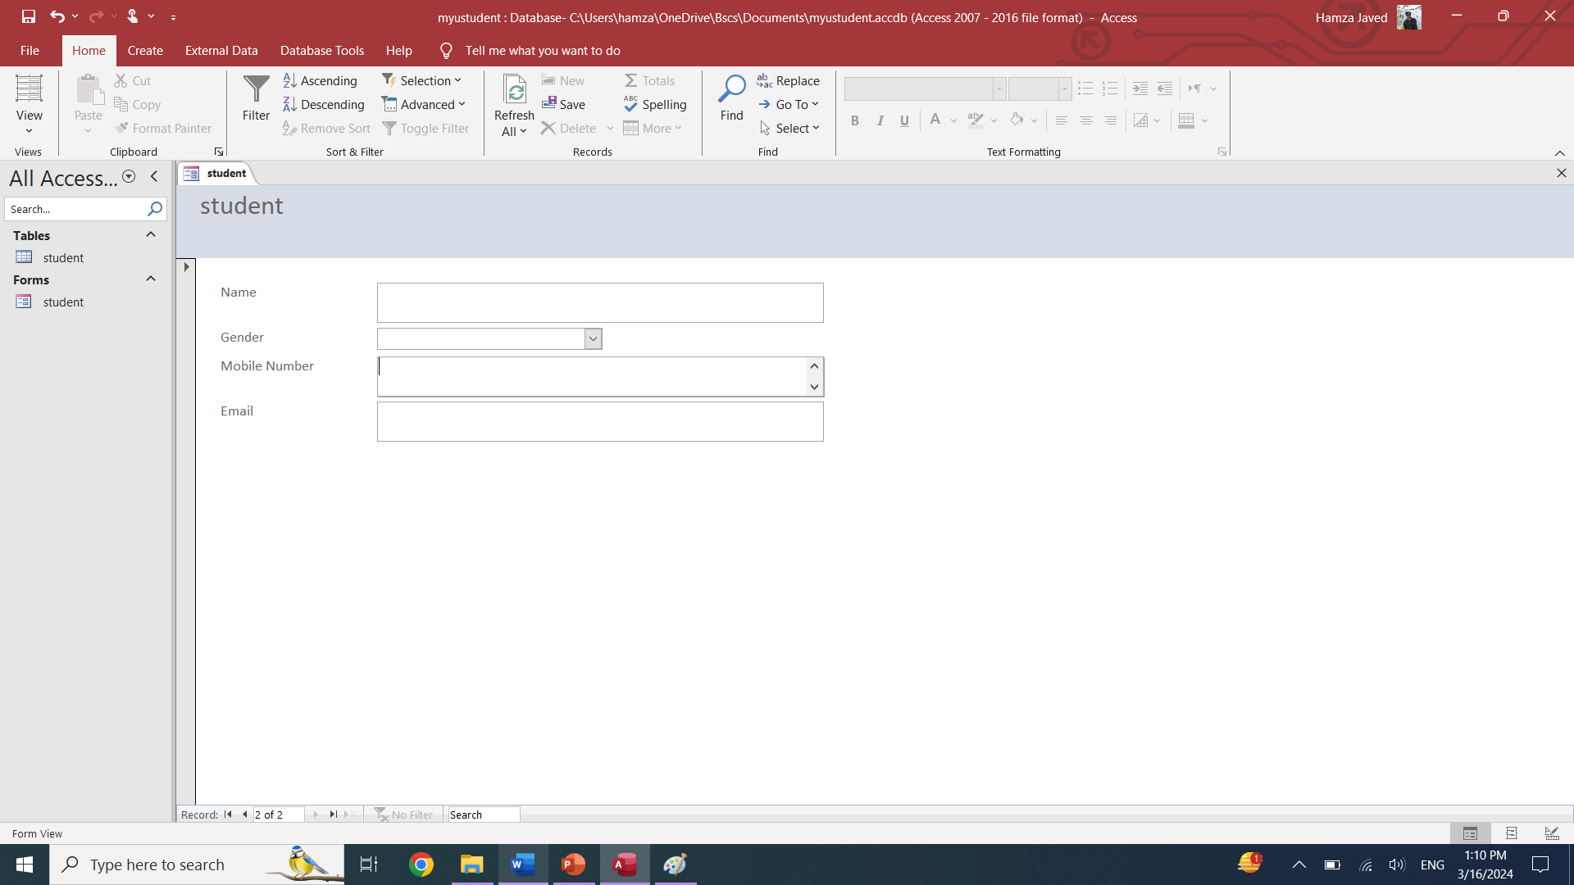

**Create a submit button to store record on table using form**

Go to forms layout tab and select Button

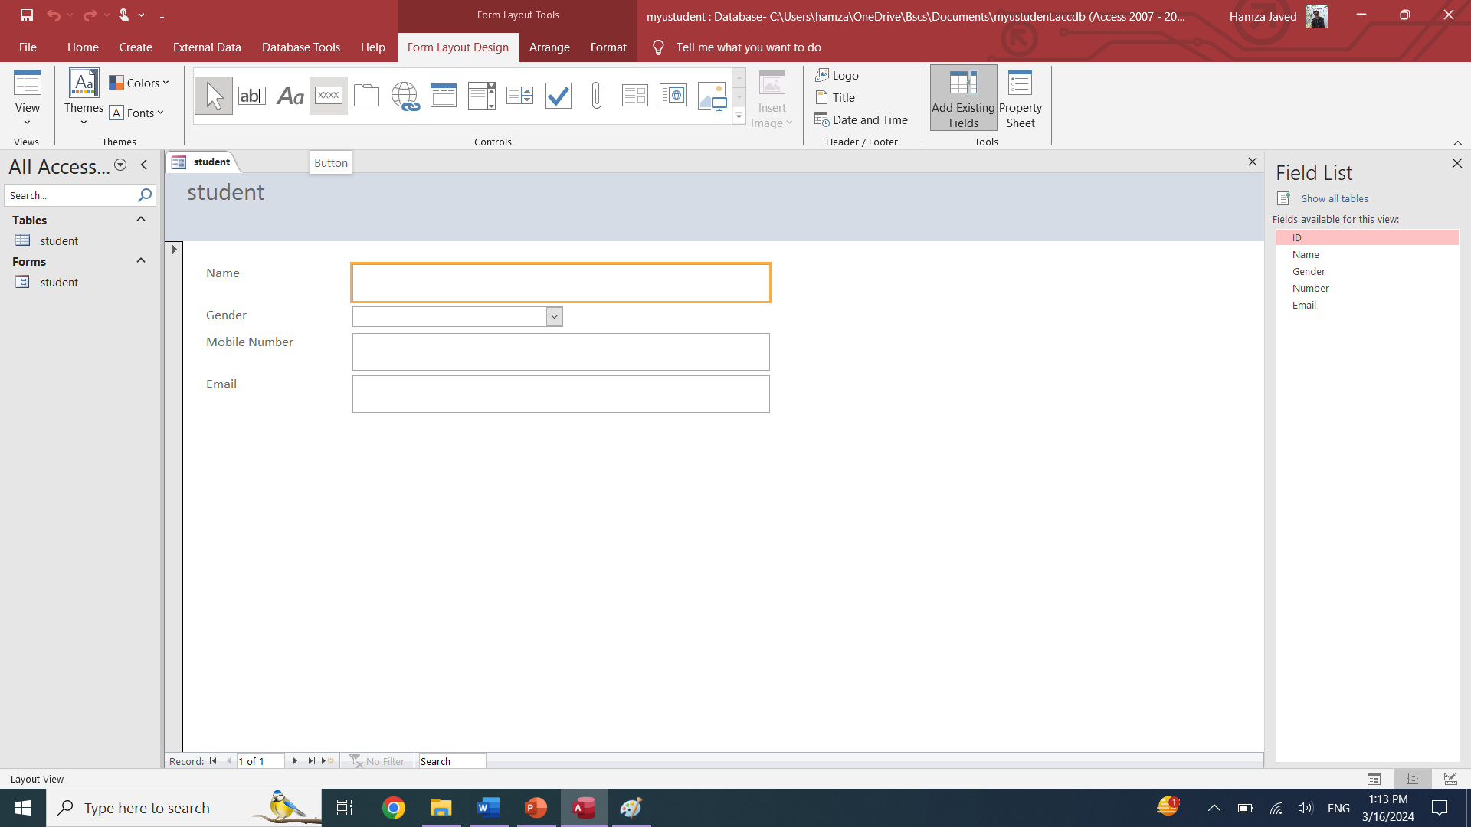

Now, select button and click desire location. The New dialogue box also open

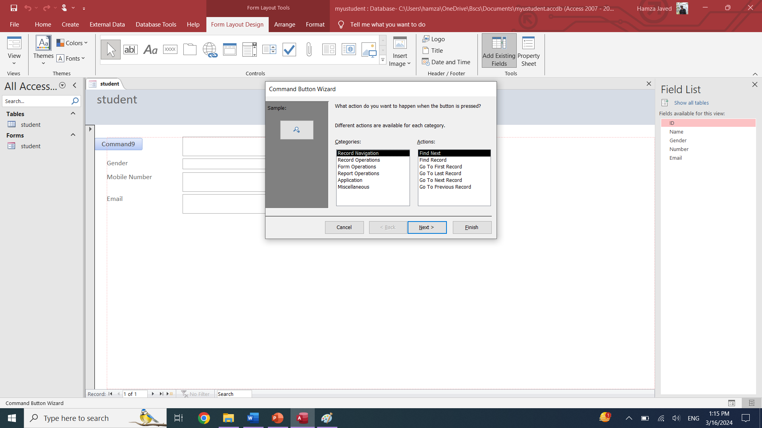

Select record operation from categories and then select save records

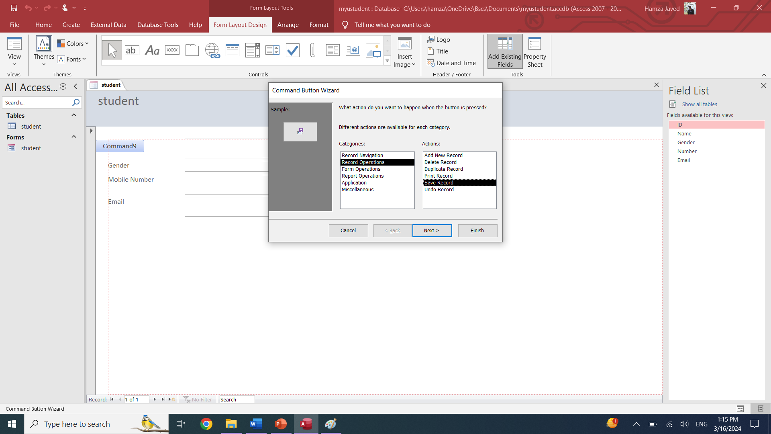

Click next and write name of button

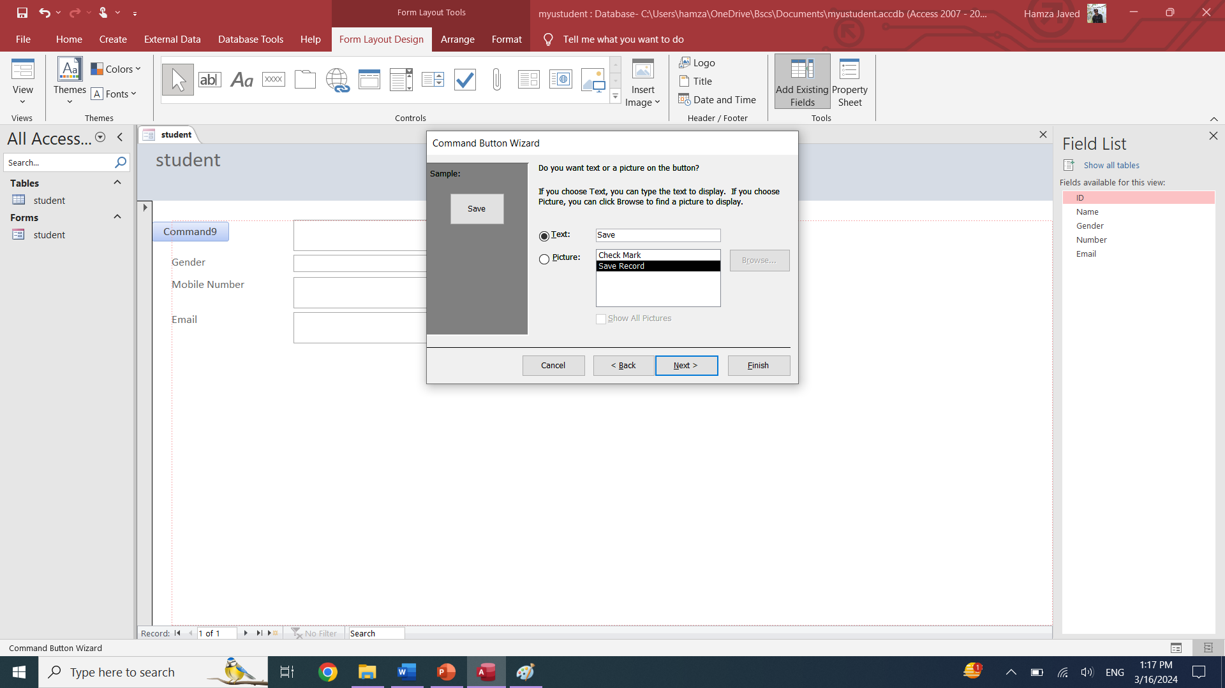

Now final form are:  
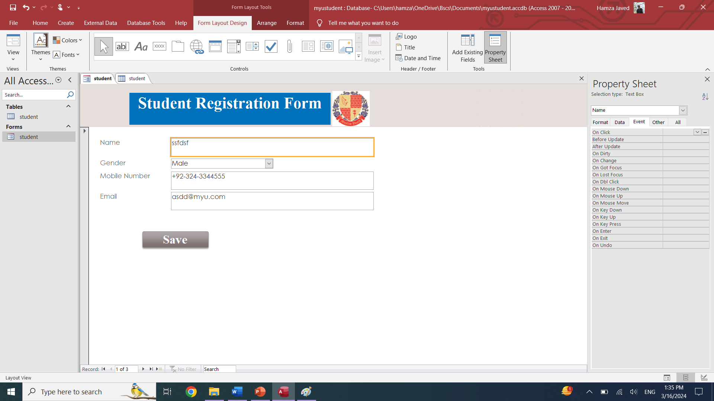

Now go to create tab and click on Report wizard

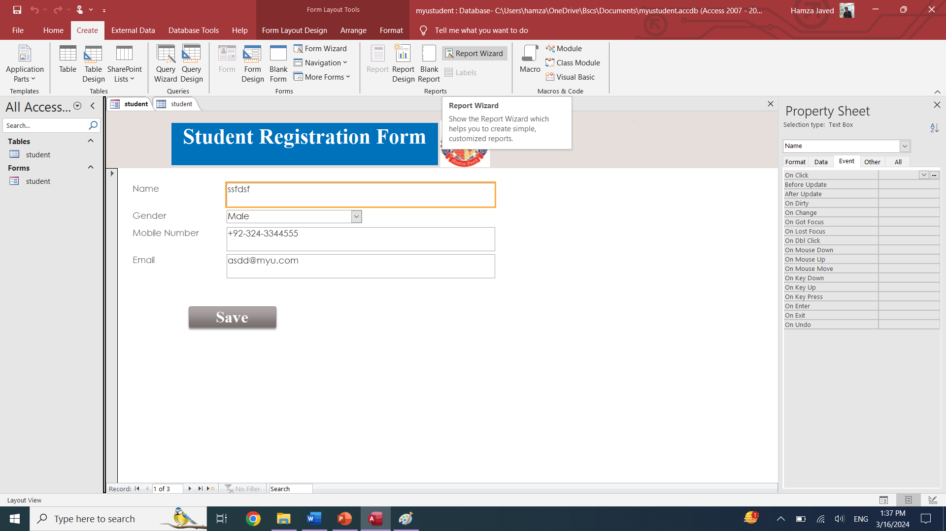

The new form wizard box will open and select items you wanted on report and click next

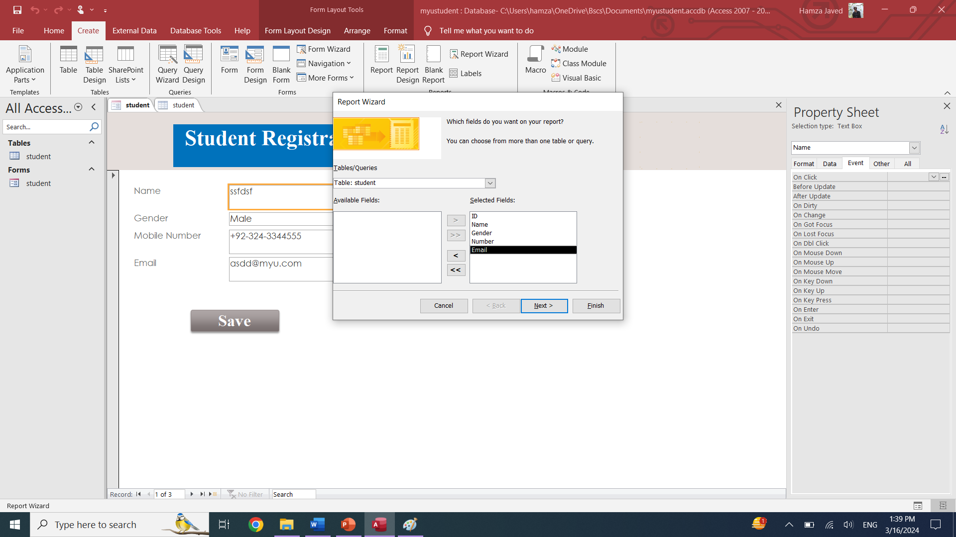

After finish following report will be shown

